# ***Challenge Name :- Sp0rts_St0r3***

**Description:**

Explore the Sports Randomizer CTF Challenge and uncover hidden vulnerabilities lurking in user input. Think outside the box as you navigate unexpected twists to find the flag in secrets of the application's security, leading to surprising exploits and unexpected victories.

**Level:** Hard

**Solution:**

In the site there was a input parameter which is vulnerable for SQLi. Let's test.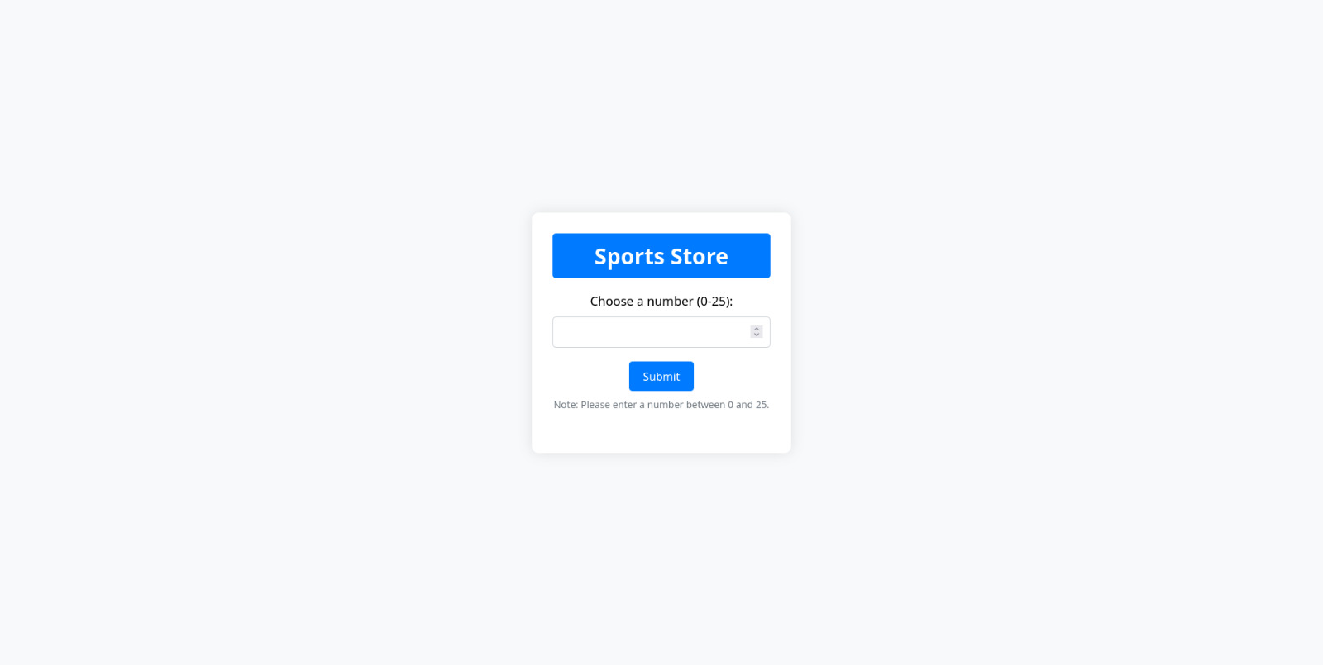

We are now performing a simple sql injection in username parameter in url bcz its vulnerable.



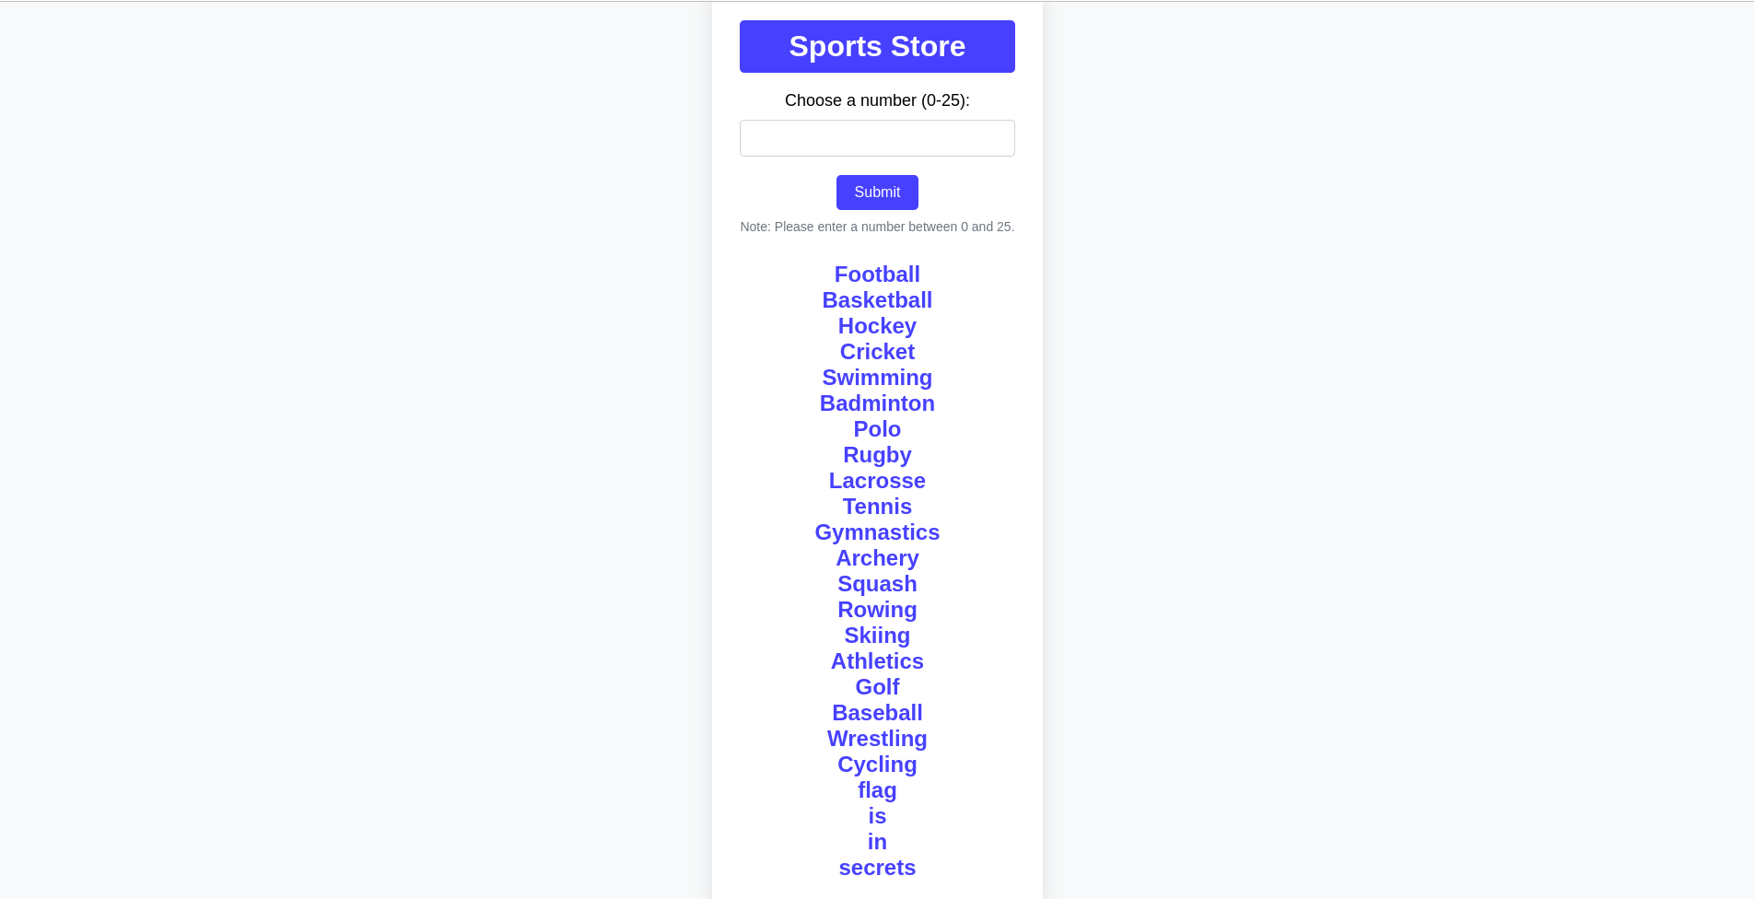

We get the flag as:

**flag{Cr1ck3t_1s_th3_b3st}**

This page is intentionally left blank